International Intensive Geometry Winter Program (IIGWP) Application Form

- Student Name

- School

- Nationality

- Date of Birth

- Grade

- Email address of the school teacher or mentor who will provide the recommendation letter

- Parent’s Email Address

Documents Required for IIGWP Application

- Application Form
-Problem Solutions
-Essay
- Mathematics Achievements and Portfolio
-Any math-related certificates, awards, or portfolio materials
-There is no limit to the number of items you may submit.

Please compress all files listed in Items 1 and 2 into a single ZIP file. The file name should be the student’s name.

Note: Recommendation letters will be requested directly from the recommender by our office.

Essay Questions
- Why are you applying to the IIGWP

- The IIGWP is conducted online. Will you be able to actively participate in the program?

- Beyond what you have learned in school, how far have you studied mathematics on your own?

- If you have participated in any math competitions, please list all of them.

Problem Set

Note : Please submit the following essay and problem solutions. You may type or handwrite your answers and submit them as a PDF or JPEG file. A total of
10 problems will be provided. We recommend solving and submitting at least 60% of them, if possible. Please write out the solution process in detail.

01.

In , bisects the exterior angle of ( is a point on ). When, , , and , find the length of .
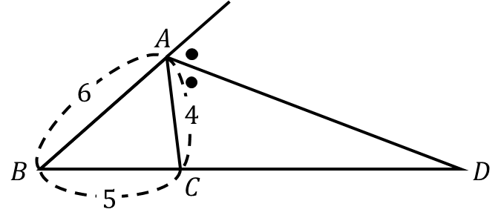

02.

As in the figure below, rhombus is given and is a point on such that . Given that and , find the area of .
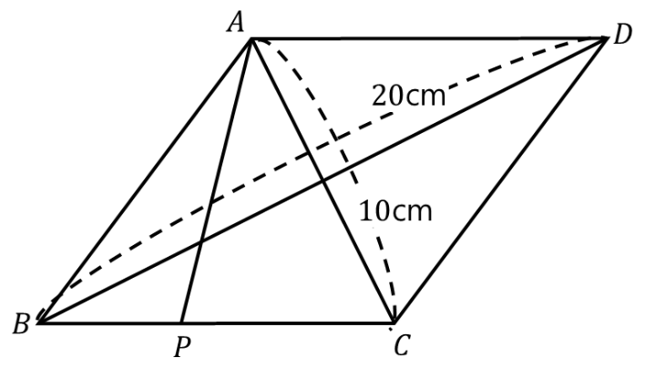

03.

Triangle has side lengths , , and . What is the height of with respect to ?
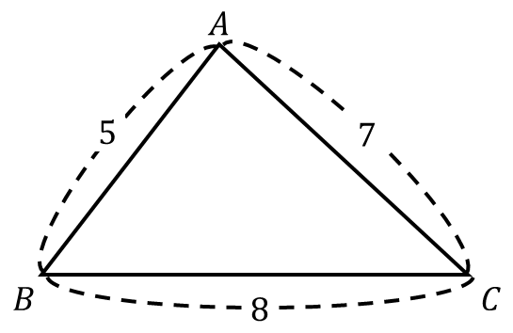

04.
Triangle has lengths , and angles . If for positive integer numbers and which are coprime, what is ?
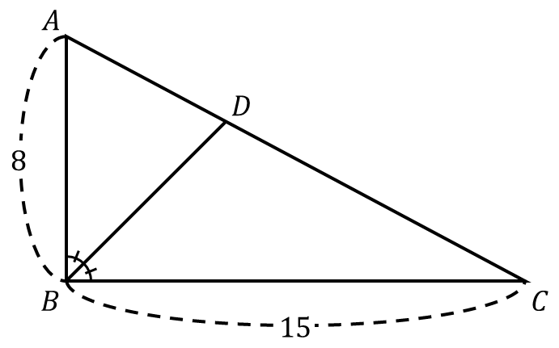

05.
As in the figure below, , , , are right triangles with , , , and . If , the perimeter of pentagon is for rational numbers , , , . What is ?
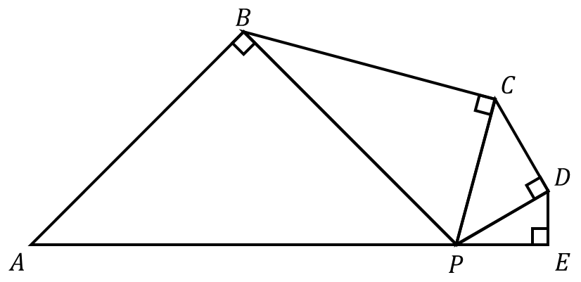

06.
As in the figure below, triangle is given. is a point on , is a point on , and is a point on such that and . If , , , and , what is the difference of and ?
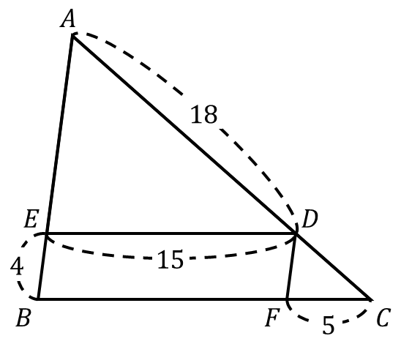
07.
Lines and are tangent to a circle centered at at points and , respectively. A third line, which is also tangent to the circle, is drawn and it intersects line segments and at points and , respectively. Given that , find the value of .

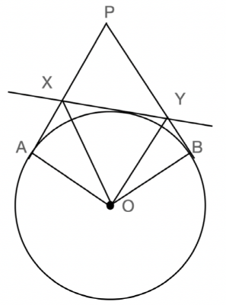
08.
As in the figure below, triangle is given, is the midpoint of , and points and are the centroid of and , respectively. If the area of is , then what is the area of ?
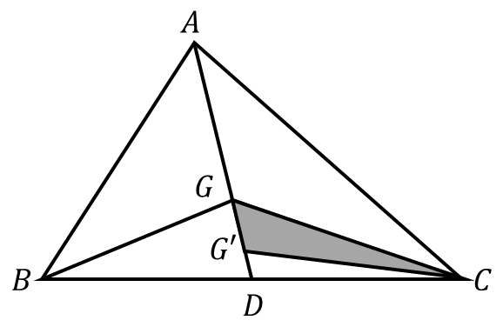

09.
A parallelogram has side lengths of and . If one of its two diagonals has a length of , then what is the length of the other diagonal?

10.
has a perimeter of 18 and . For the perpendicular foot from to , . What is the height of with regard to ?
